# Grid user

Mkdir /u01/app/18.0.0/grid

Cd /TEMP

Unzip LINUX.X64_180000_grid_home.zip -d /u01/app/18.0.0/grid

Cd /u01/app/18.0.0/grid

./gridSetup.sh

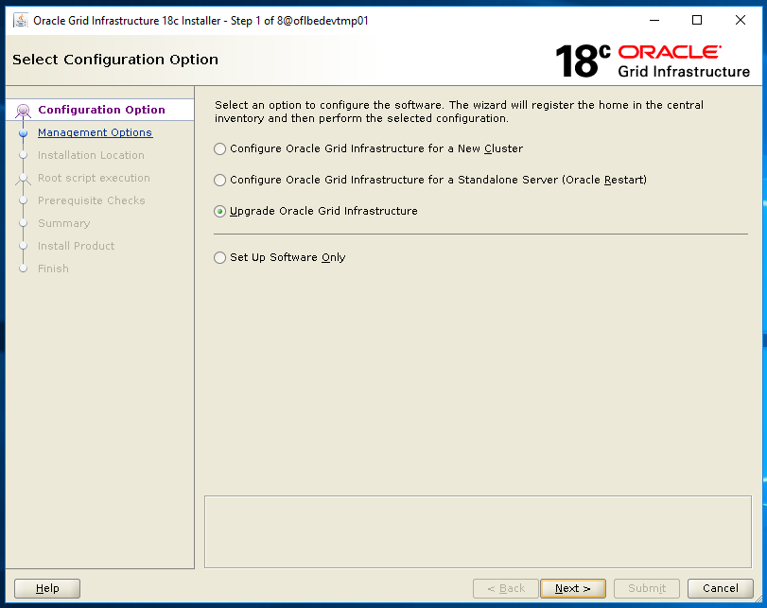

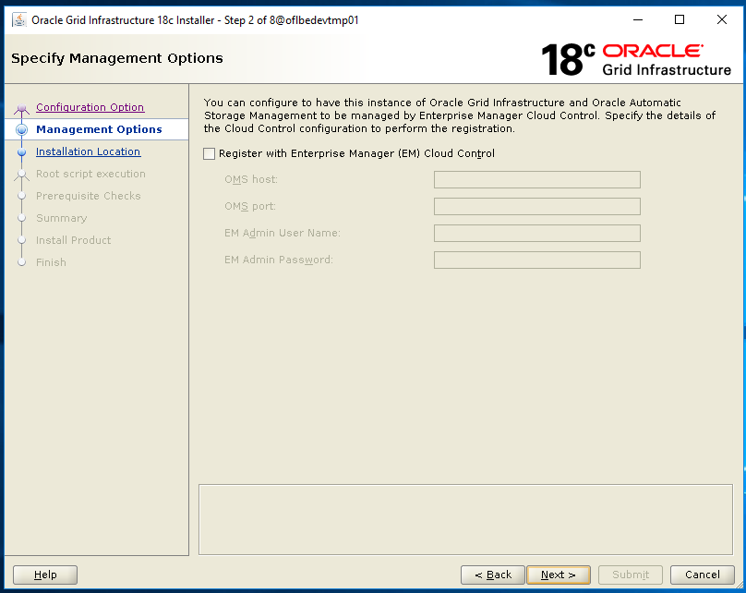

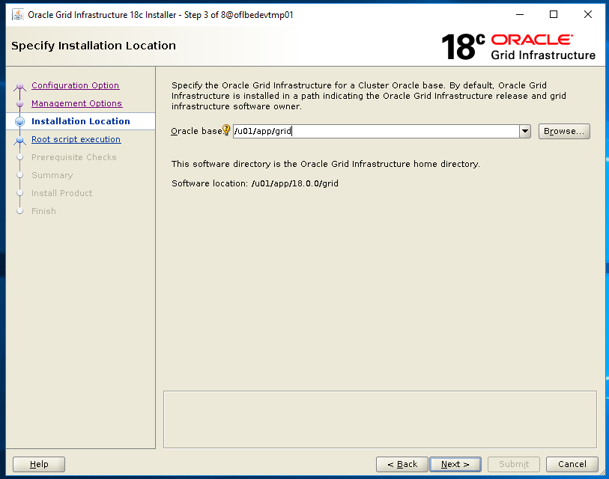

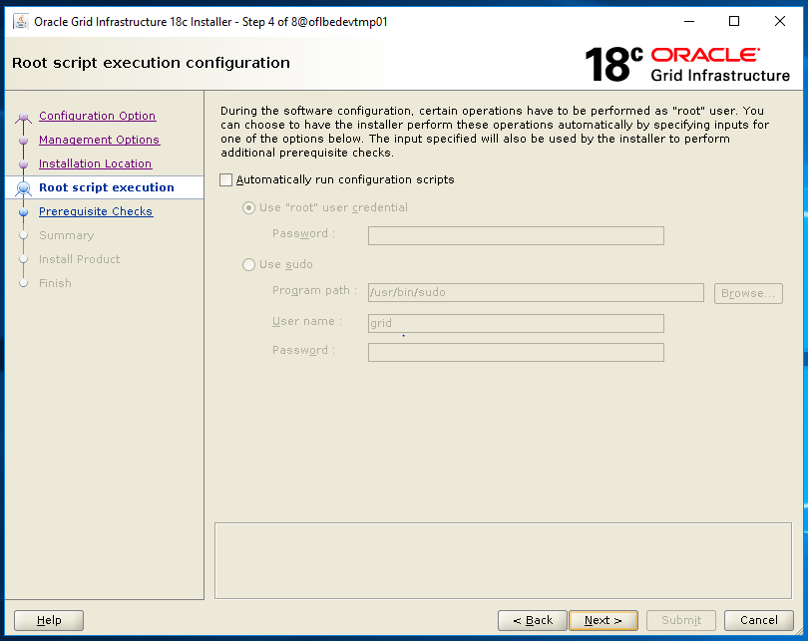

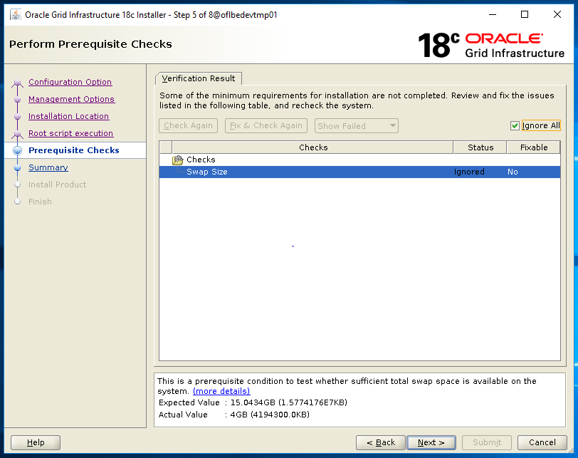

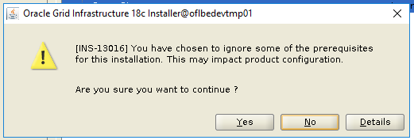

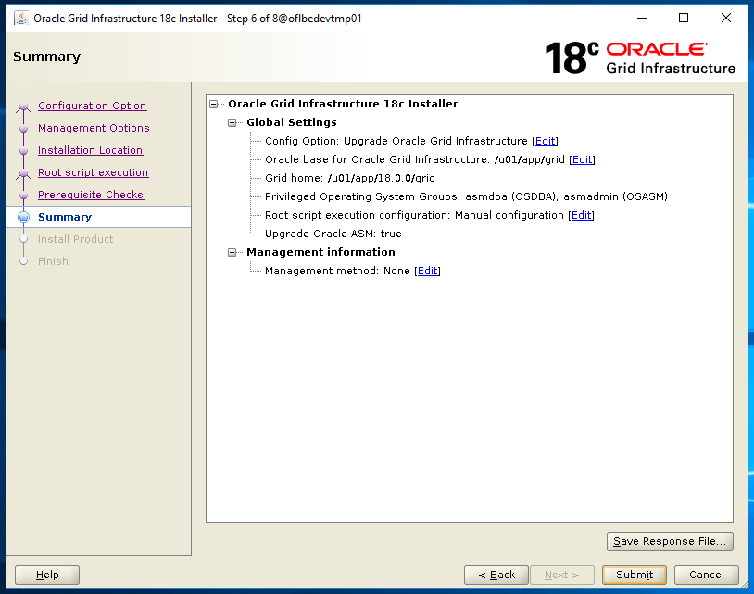

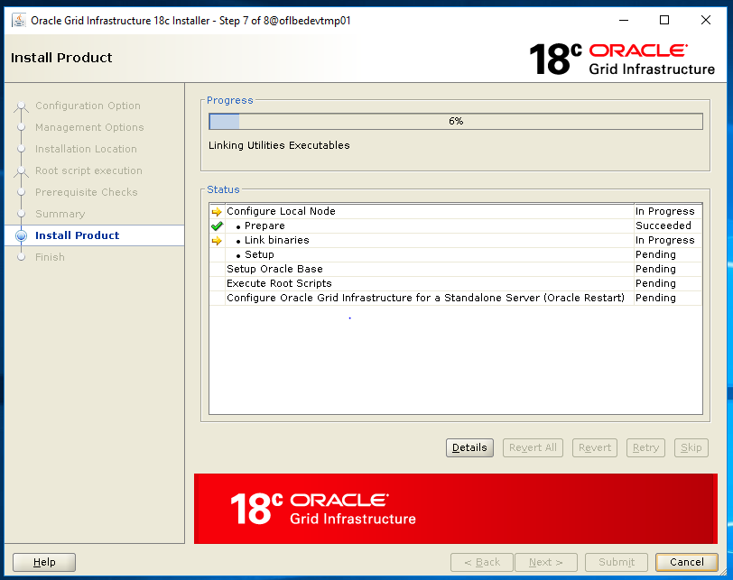

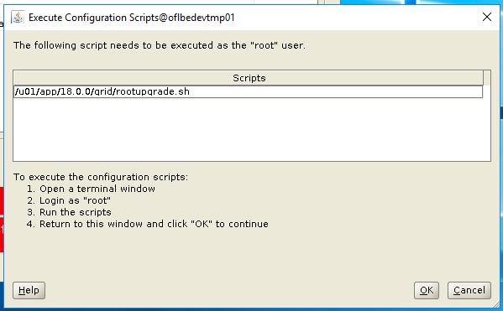



|  |
| --- |
|  |

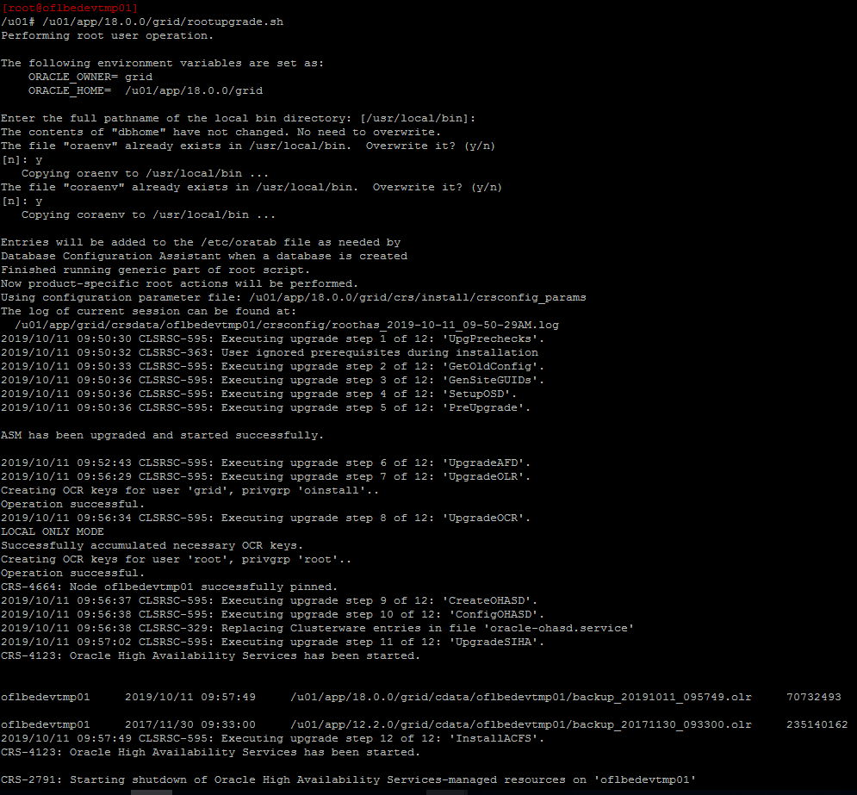

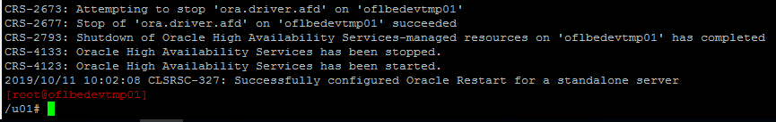

Return to the Installer and continue

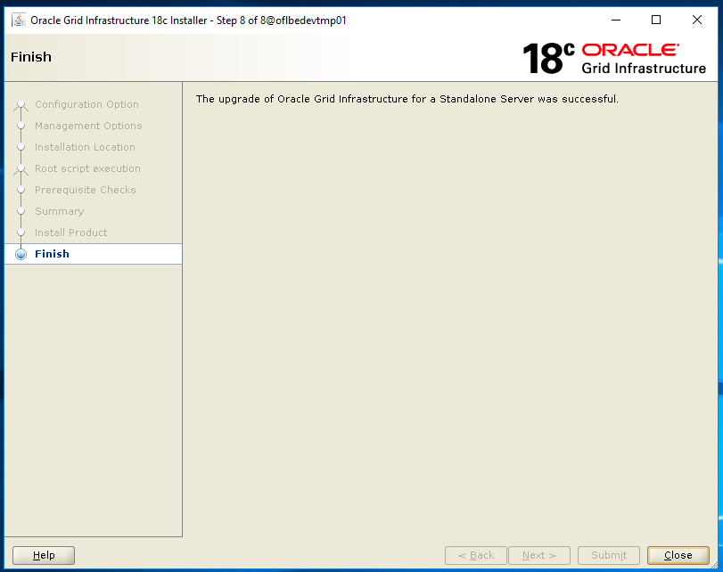

Vi $HOME/.bash_profile

Change the ORACLE_HOME from 12.2.0 to 18.0.0

Upgrade OPatch

unzip p6880880_180000_Linux-x86-64.zip -d /u01/app/18.0.0/grid

# 18.7 patch

# root

Cd /TEMP

Chmod -R 775 29708703

export ORACLE_SID=+ASM

export ORACLE_BASE=/u01/app/grid

export ORACLE_HOME=/u01/app/18.0.0/grid

export PATH=$ORACLE_HOME/bin:$PATH

$ORACLE_HOME/OPatch/opatchauto apply /TEMP/29708703 -analyze -oh $ORACLE_HOME

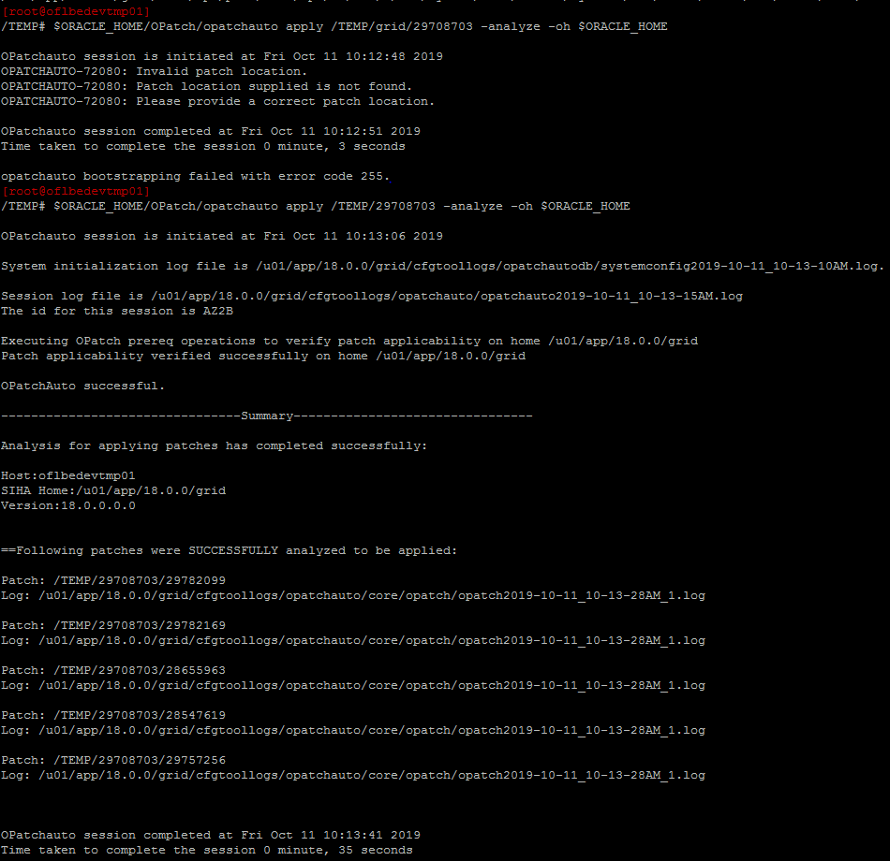

$ORACLE_HOME/OPatch/opatchauto apply /TEMP/29708703 -oh $ORACLE_HOME

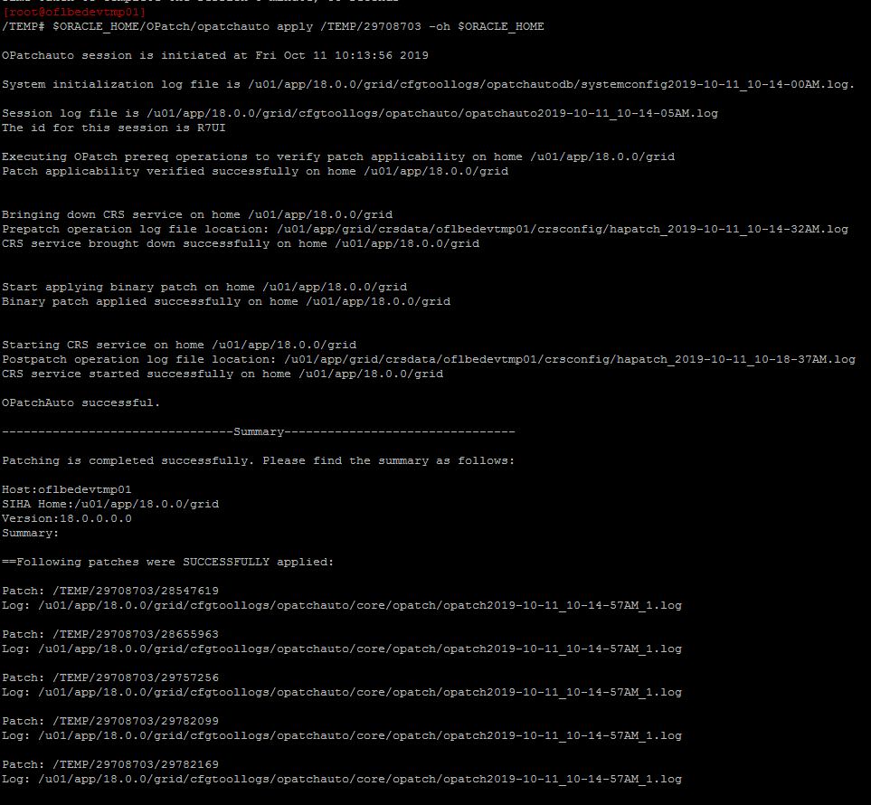

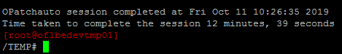

# Cleanup

At this point we can remove the old 12.2.0 ORACLE_HOME

Detach the ORACLE_HOME from the inventory so we can remove the files.

/u01/app/12.2.0/grid/oui/bin/runInstaller -detachHome ORACLE_HOME=/u01/app/12.2.0/grid

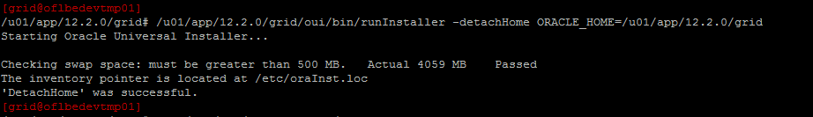

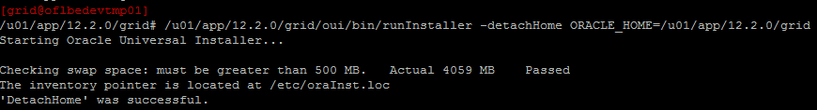

Verify

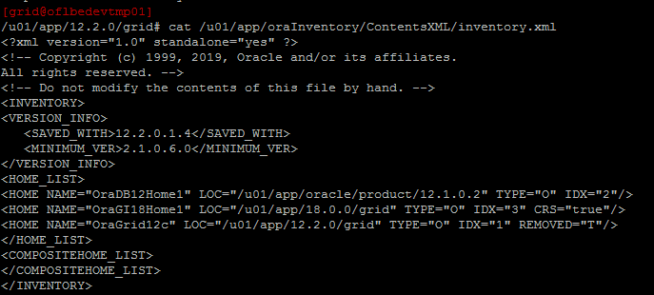

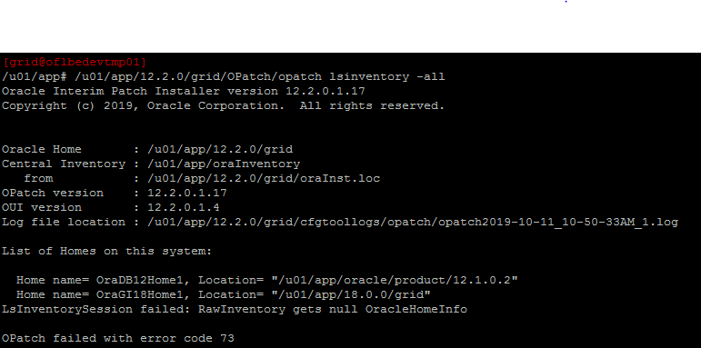

Remove the files



# DB

# Oracle

Cd /TEMP

Mkdir /u01/app/oracle/product/18.0.0.0

unzip LINUX.X64_180000_db_home.zip -d /u01/app/oracle/product/18.0.0.0

# Install ORACLE_HOME

export ORACLE_HOME=/u01/app/oracle/product/18.0.0.0

export ORACLE_BASE==/u01/app/oracle

export PATH=$PATH:$ORACLE_HOME/bin

$ORACLE_HOME/runInstaller

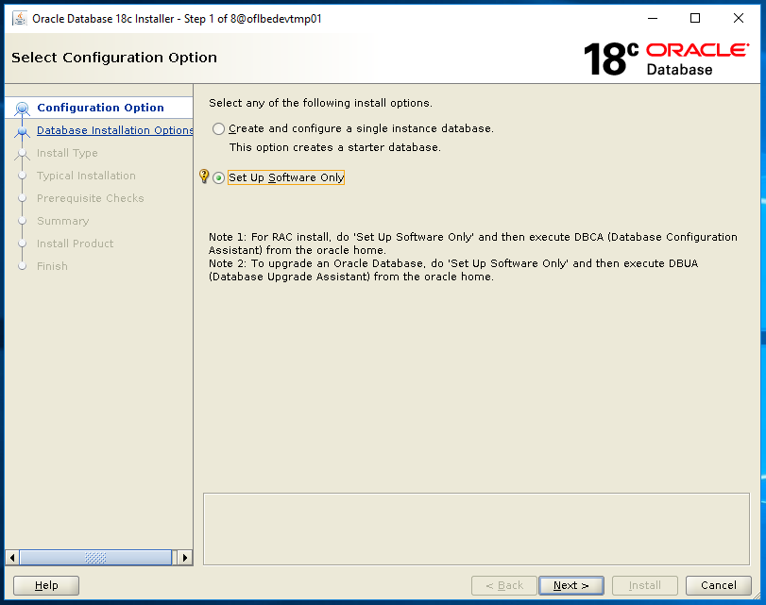

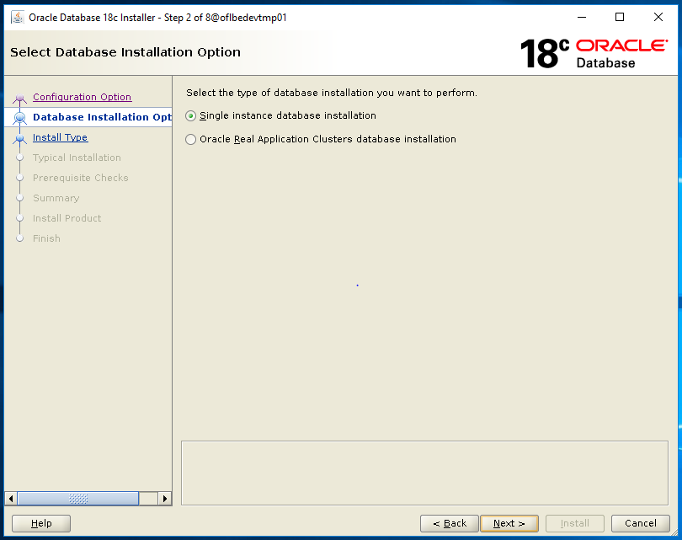

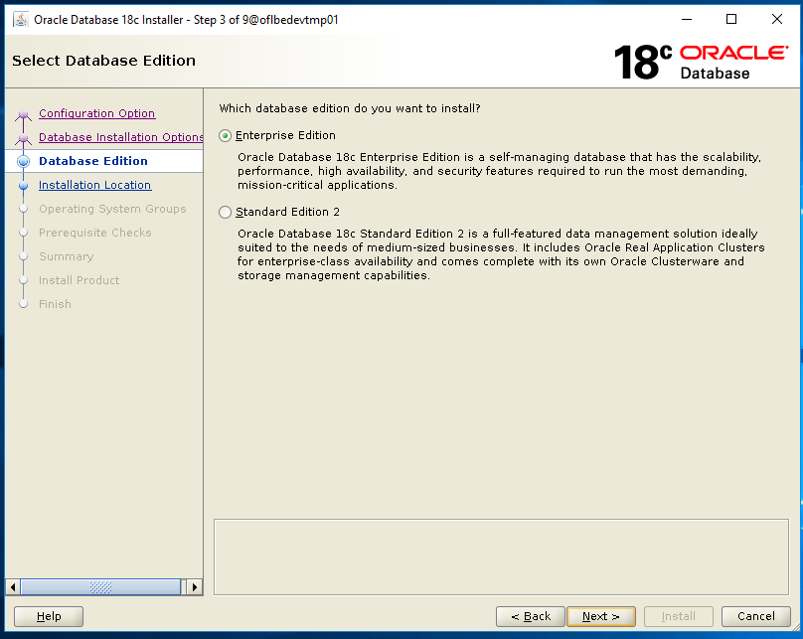

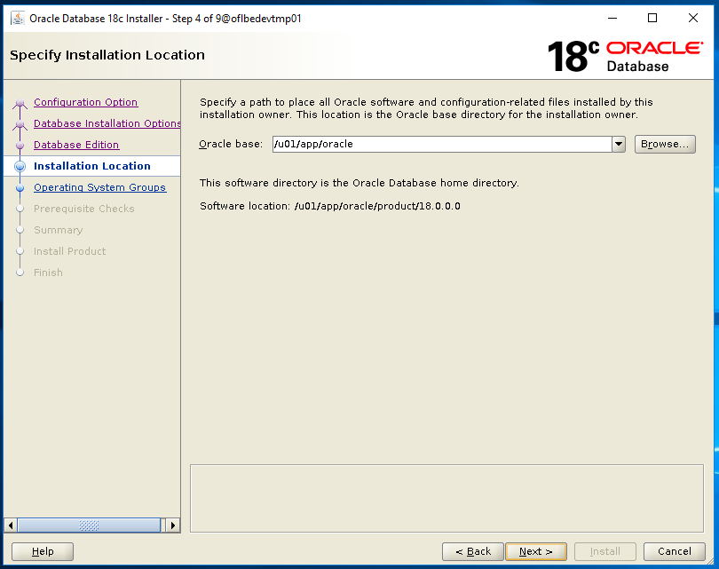

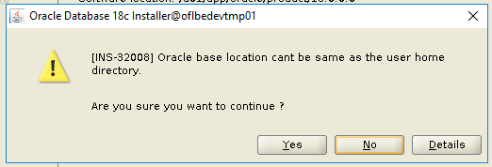

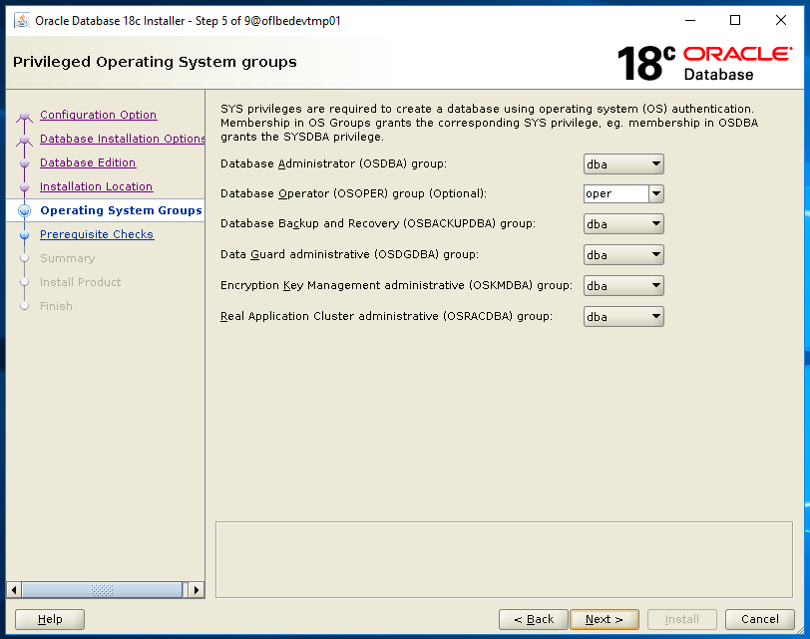

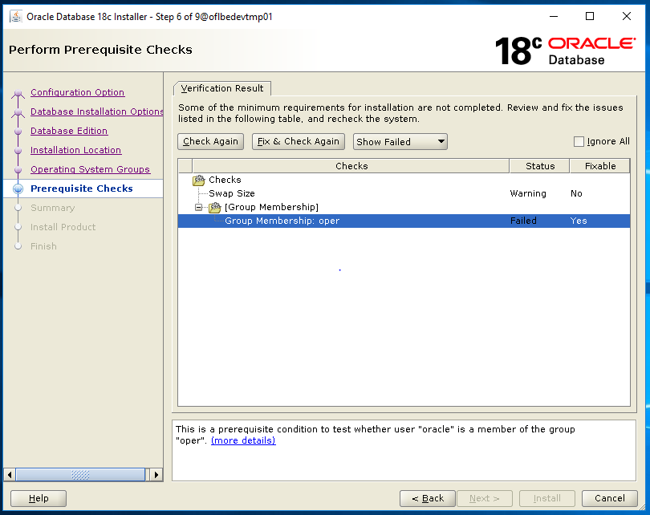

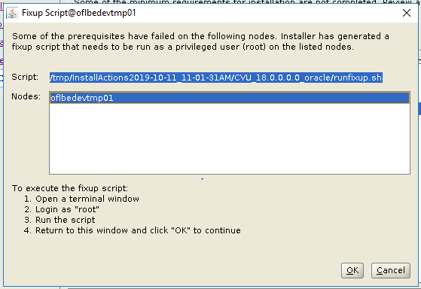

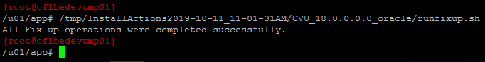

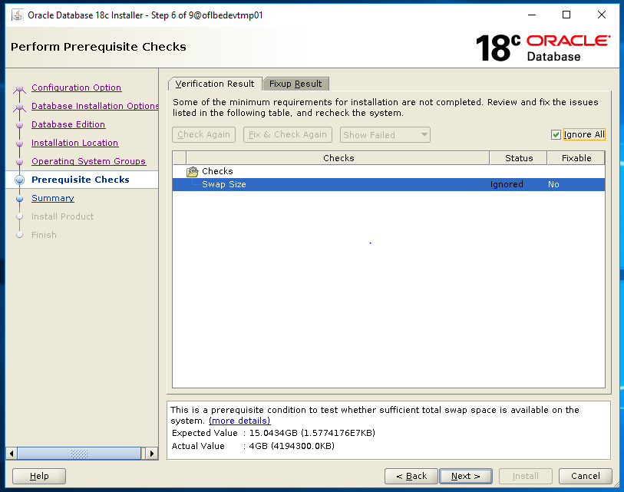

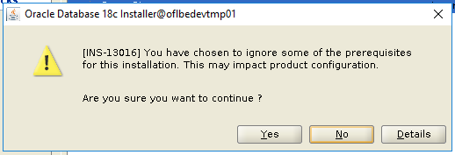

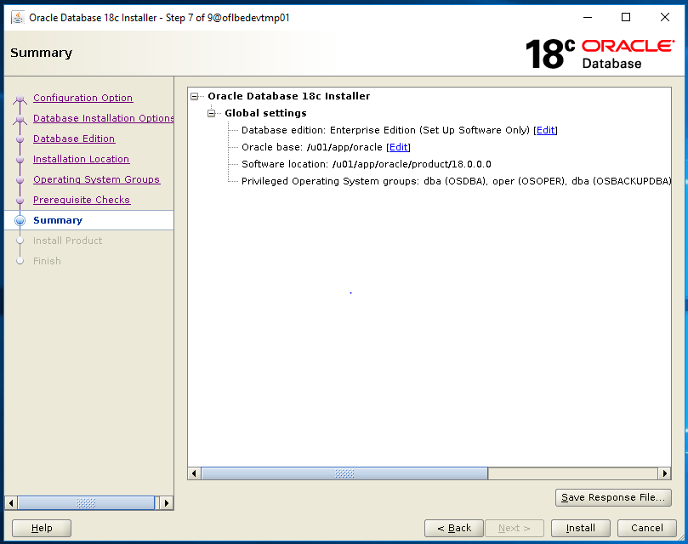

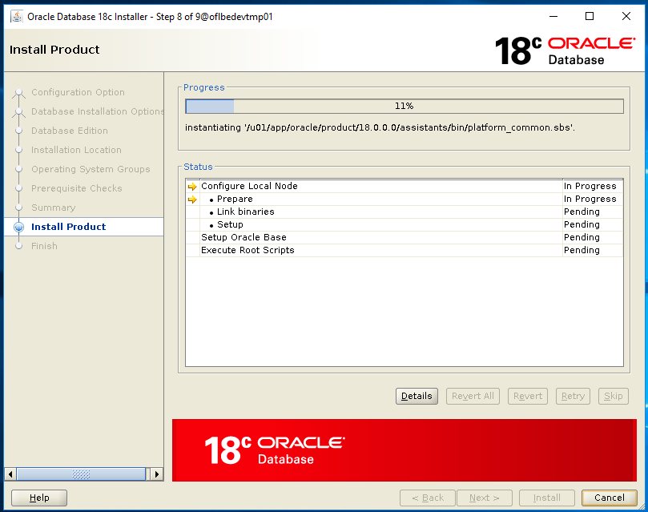

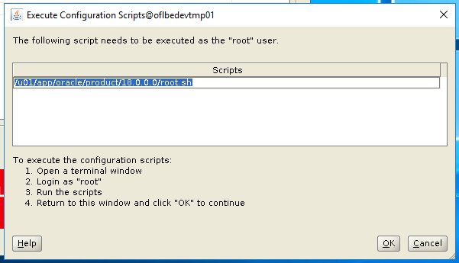

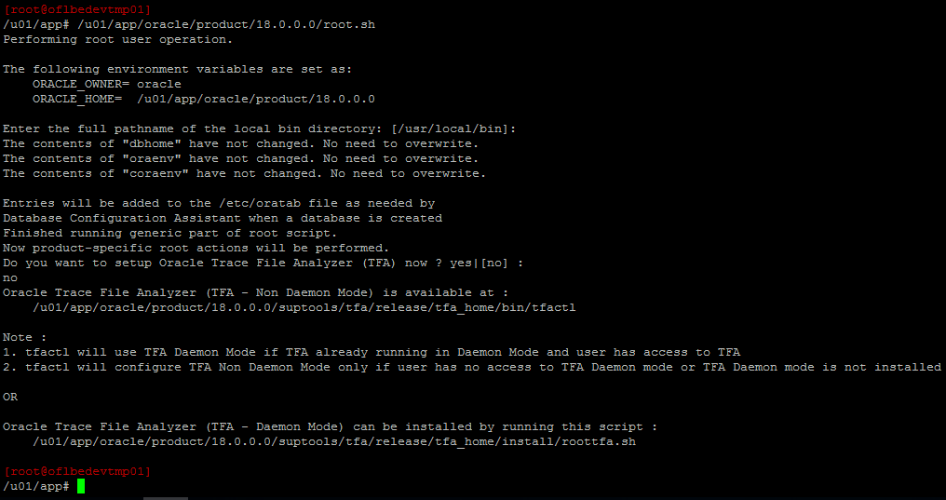

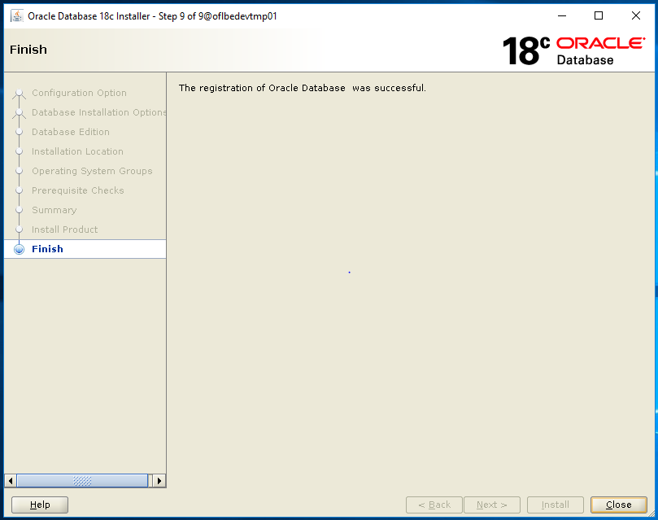

unzip p6880880_180000_Linux-x86-64.zip -d /u01/app/oracle/product/18.0.0.0

# Oracle

Cd /TEMP

Unzip p29757256_180000_Linux-x86-64.zip

export ORACLE_HOME=/u01/app/oracle/product/18.0.0.0

export PATH=/usr/local/bin:/bin:/usr/bin:/usr/local/sbin:/usr/sbin:$ORACLE_HOME/bin

cd 29757256

$ORACLE_HOME/OPatch/opatch prereq CheckConflictAgainstOHWithDetail -ph ./

$ORACLE_HOME/OPatch/opatch apply

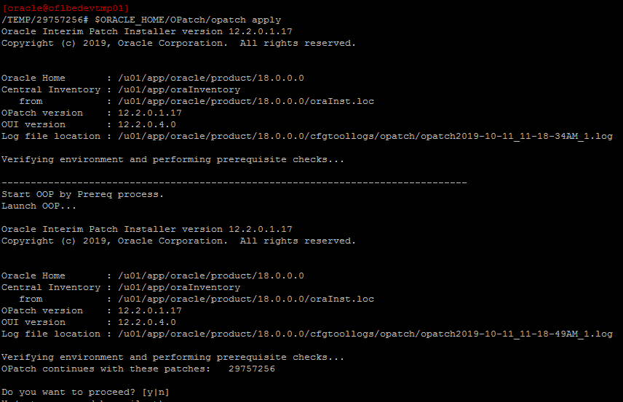

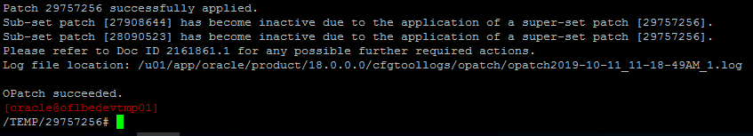

unzip p29774410_180000_Linux-x86-64.zip

cd 29774410

$ORACLE_HOME/OPatch/opatch prereq CheckConflictAgainstOHWithDetail -ph ./

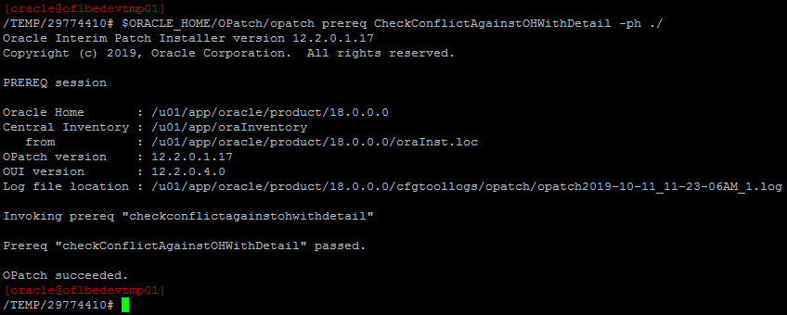

$ORACLE_HOME/OPatch/opatch apply

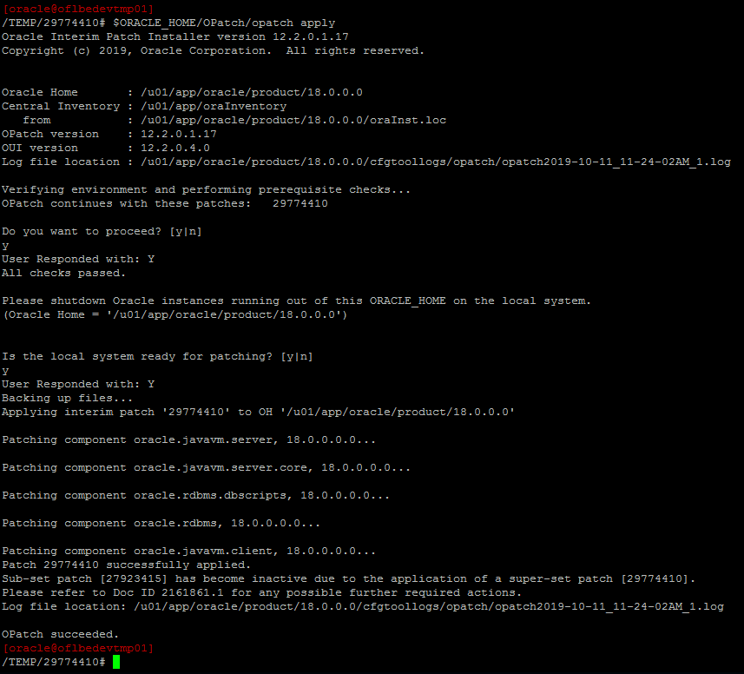

# Database

Set your ORACLE_SID

Export ORACLE_SID=<DB>

Export ORACLE_HOME=/u01/app/oracle/product/12.1.0.2

Export PATH= /usr/local/bin:/bin:/usr/bin:/usr/local/sbin:/usr/sbin:/u01/app/oracle/product/12.1.0.2/bin

$ORACLE_BASE/product/18.0.0.0/jdk/bin/java -jar $ORACLE_BASE/product/18.0.0.0/rdbms/admin/preupgrade.jar TERMINAL TEXT

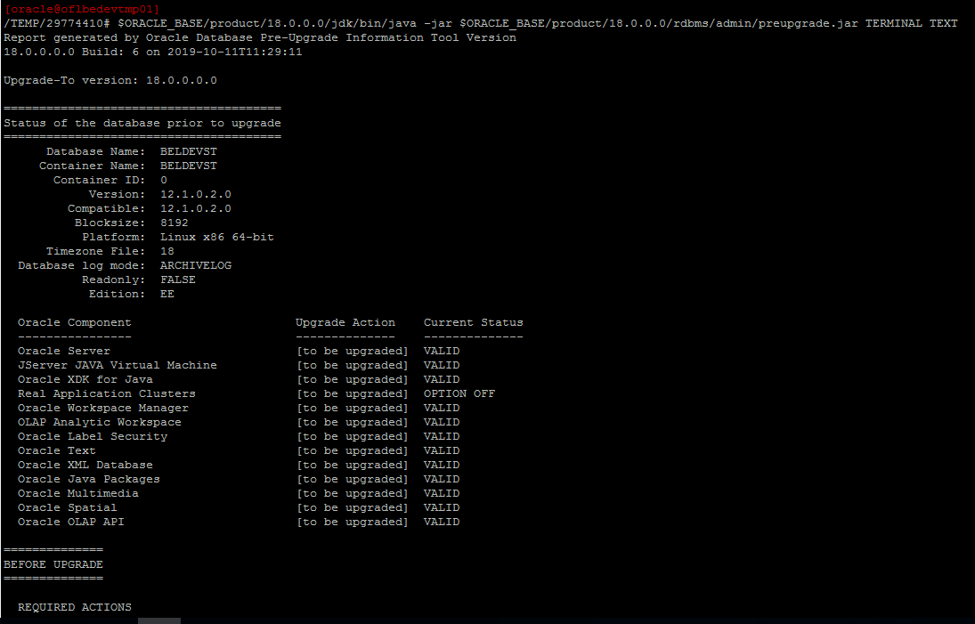

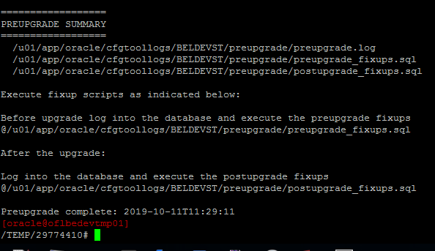

@/u01/app/oracle/cfgtoollogs/BELDEVST/preupgrade/preupgrade_fixups.sql

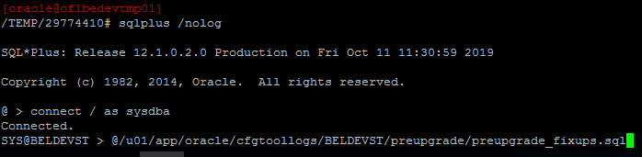

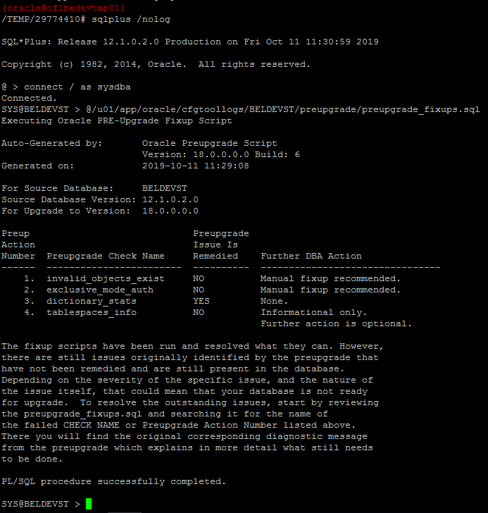

srvctl stop database -d BELDEVST

cp $ORACLE_HOME/dbs/*BELDEVST* $ORACLE_BASE/product/18.0.0.0/dbs

export ORACLE_SID=BELDEVST

export ORACLE_BASE=/u01/app/oracle

export ORACLE_HOME=/u01/app/oracle/product/18.0.0.0

export PATH=/usr/local/bin:/bin:/usr/bin:/usr/local/sbin:/usr/sbin:$ORACLE_HOME/bin

startup upgrade

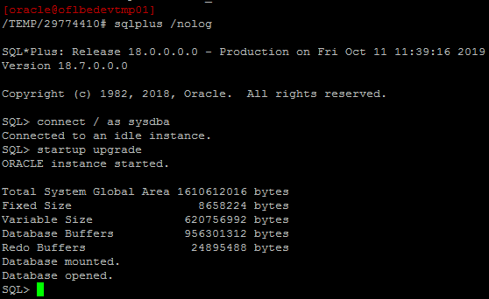

$ORACLE_HOME/bin/dbupgrade

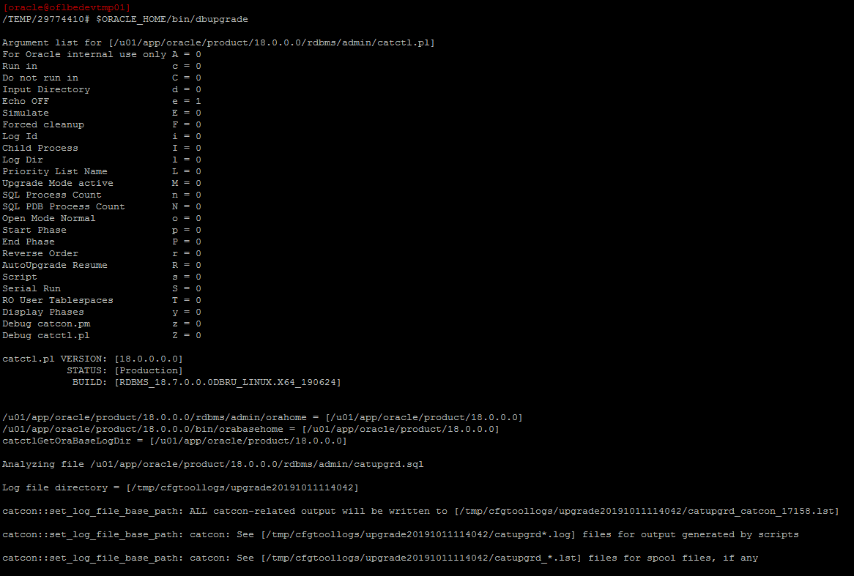

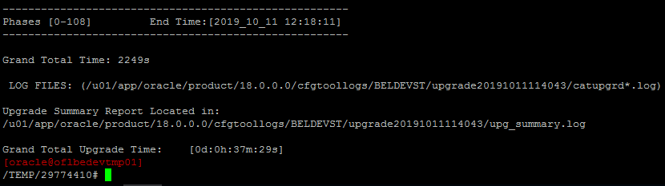

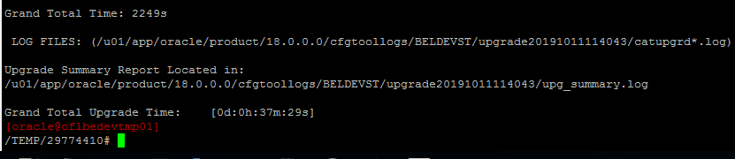

vi /u01/app/oracle/product/18.0.0.0/cfgtoollogs/BELDEVST/upgrade20191011114043/upg_summary.log

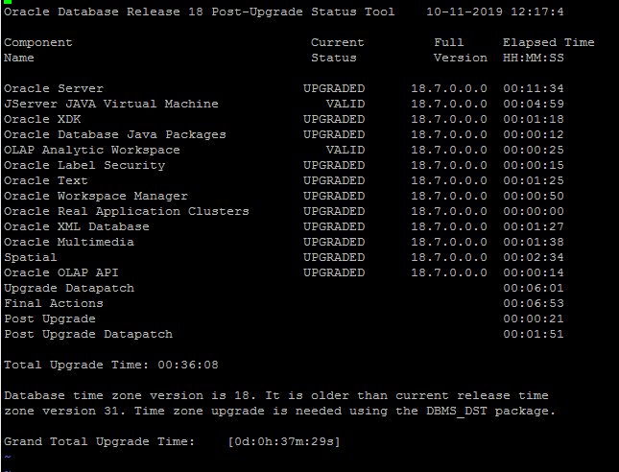

Startup upgrade

SET SERVEROUTPUT ON

DECLARE

l_tz_version PLS_INTEGER;

BEGIN

SELECT DBMS_DST.get_latest_timezone_version

INTO l_tz_version

FROM dual;

DBMS_OUTPUT.put_line('l_tz_version=' || l_tz_version);

DBMS_DST.begin_upgrade(l_tz_version);

END;

/

SHUTDOWN IMMEDIATE;

STARTUP;

SET SERVEROUTPUT ON

DECLARE

l_failures PLS_INTEGER;

BEGIN

DBMS_DST.upgrade_database(l_failures);

DBMS_OUTPUT.put_line('DBMS_DST.upgrade_database : l_failures=' || l_failures);

DBMS_DST.end_upgrade(l_failures);

DBMS_OUTPUT.put_line('DBMS_DST.end_upgrade : l_failures=' || l_failures);

END;

/

SELECT * FROM v$timezone_file;

@/u01/app/oracle/cfgtoollogs/BELDEVST/preupgrade/postupgrade_fixups.sql

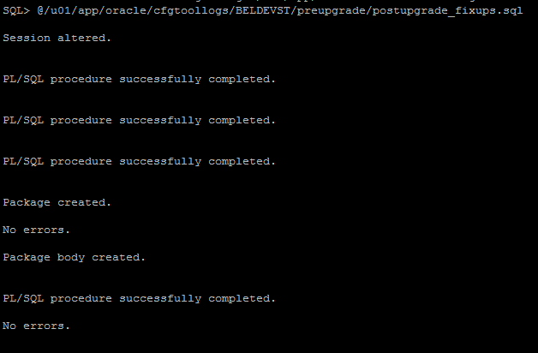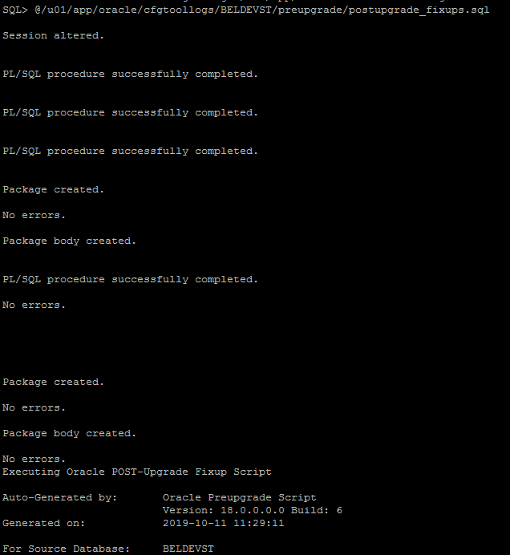

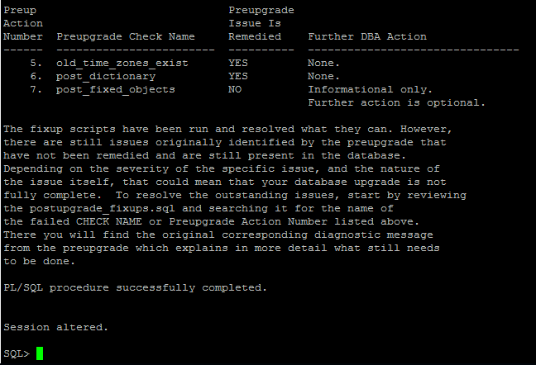

Sqlplus /nolog

Connect / as sysdba

alter system set compatible='18.7.0.0.0' scope=spfile;

shutdown immediate

srvctl upgrade database -d BELDEVST -o /u01/app/oracle/product/18.0.0.0

srvctl config database -d BELDEVST -verbose

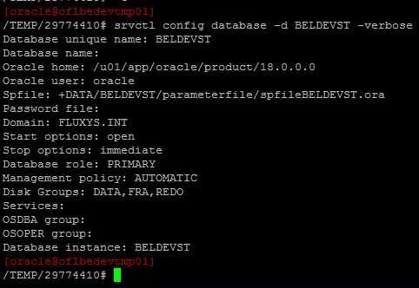

vi /etc/oratab

update the ORACLE_HOME for the database